NEWS RELEASE
FOR IMMEDIATE RELEASE: February 4, 2015
MEDIA CONTACT: Joey Eschrich | 480-442-2682 | joey.eschrich@asu.edu

EMERGE 2015: ARTISTS AND SCIENTISTS REDESIGN THE FUTURE AT ASU’S SKYSONG CENTER

Radiolab’s Jad Abumrad joins a host of artists, engineers, designers, scientists, storytellers, technologists and other creatives on Friday, March 6,
to build the future of choices and values

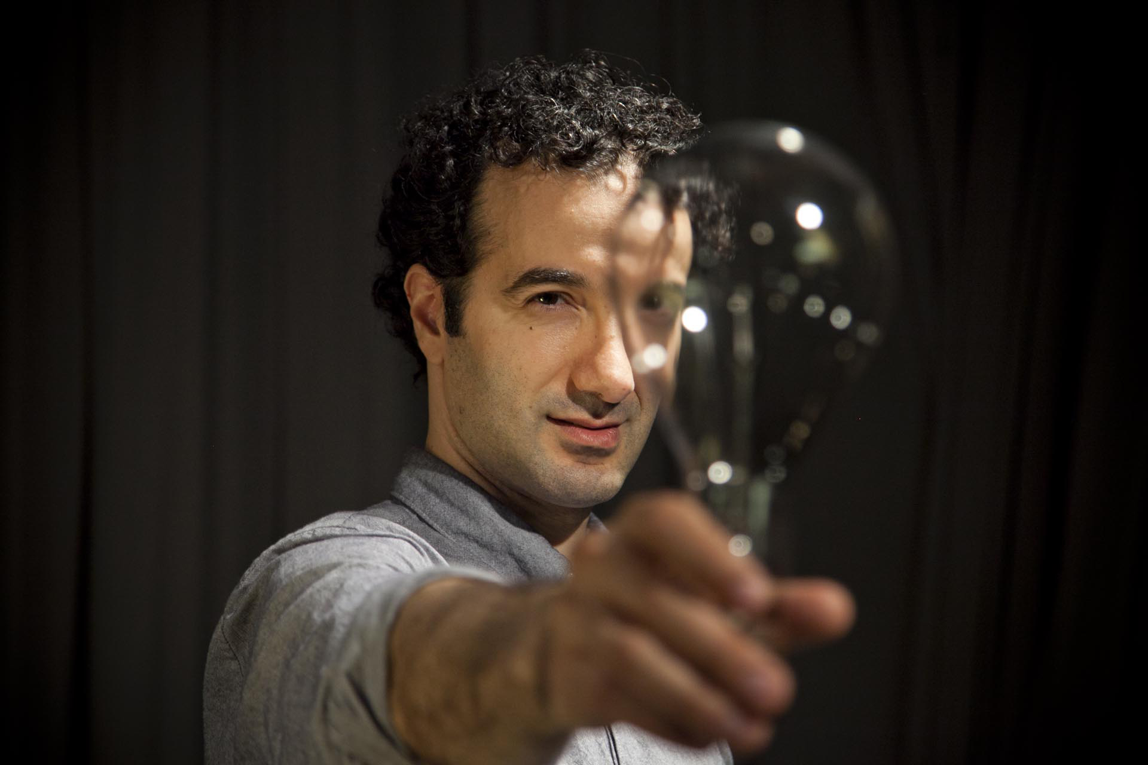

Arizona State University’s Emerge 2015 will showcase its radically new visions of the future on Friday, March 6, at the university’s SkySong Innovation Center in Scottsdale. The featured visionary – Radiolab host, creator and MacArthur “genius” Jad Abumrad – will join ten spellbinding “visitations from the future,” including theatrical performances, improvisation, games, dance and hands-on opportunities to design and build the future.

The event from 3:00 pm to midnight is free and open to the public, with registration requested through asuemerge2015.eventbrite.com.

The theme of Emerge 2015 (emerge.asu.edu) is The Future of Choices and Values. “Humans today have unprecedented power to harness and reshape matter, energy and even life itself. Emerge asks what kinds of futures we should build together, at a moment in history when what we can do is almost unlimited,” says Joel Garreau, founding co-director of Emerge and Professor of Law, Culture and Values at ASU’s Sandra Day O’Connor College of Law.

Emerge dares brilliant creative and technical minds to bring these questions to life through performance, technology and storytelling. The event gathers artists, designers, scientists, engineers and audiences to imagine optimistic, thoughtful futures. Part performance, part hands-on interactive experience, Emerge explores the ways we are already creating the future, and asks us to think about how we ensure it is the future we hope for – rather than one we dread. Each of the ten “visitations from the future,” as well as the performance by Abumrad, are different ways of responding to the open question about what kind of futures we can envision, and what kind of futures we want. Because the teams behind each of the visitations are drawn from such diverse backgrounds, their answers could not be more different.

“There’s a really wide range of experiences at Emerge this year. I’m especially excited to see how seriously Emerge takes the idea of play, and how the teams are incorporating opportunities for the audience to express their ideas creatively,” says Megan Halpern, director of collaboration and research for Emerge 2015.

Jad Abumrad, the headliner for this year’s event, is the creator and host of Radiolab, the popular public radio show about “curiosity” broadcast on over 500 stations across the nation and downloaded more than 9 million times a month as a podcast. In his Peabody Award-winning program, Abumrad combines journalism, storytelling, dialogue and music to craft compositions of exploration and discovery. At Emerge, his exciting performance called “Gut Churn” – which includes video and live sound manipulation – begins with a simple question: what does it mean to “innovate?” How does it feel to make something new in the world? On one level, this is a personal story of how Jad invented a new aesthetic. On another, it is a clinic in the art of storytelling. On a third and more profound level, the lecture is the result of a three-year investigation into the science, philosophy and art of uncertainty, which all began with the two words in his title – gut churn. What use do negative feelings have during the creative process? Do those feelings get in the way, or do they propel us forward?

Abumrad will be joined at Emerge 2015 by a host of talented artists, thinkers and creators, including Jonathon Keats, conceptual artist, Forbes art critic, and novelist; Don Marinelli, co-founder of the world-renowned Carnegie Mellon Entertainment Technology Center (ETC); Rachel Bowditch, theatre director and associate professor at ASU’s School of Film, Dance and Theatre; Toby Fraley, Pittsburgh-based artist and creator of the exhibition The Secret Life of Robots; Megan Halpern, co-founder of Redshift Productions, an arts-science performance and outreach company and postdoctoral researcher at ASU’s Center for Nanotechnology in Society; and many others.

Emerge 2015’s ASU sponsors and partners include the Herberger Institute for Design and the Arts, the Julie Ann Wrigley Global Institute of Sustainability, the Consortium for Science, Policy and Outcomes, the Ira A. Fulton Schools of Engineering, the Center for Science and the Imagination, the SkySong Innovation Center, the Office of the President, the Office of Knowledge Enterprise Development, the School of Earth and Space Exploration, the Sandra Day O’Connor College of Law, LightWorks and the ASU Art Museum. Additional sponsors and partners include KJZZ 91.5, Scottsdale Public Art, Whole Foods Market and the Arizona SciTech Festival.

The ten “visitations from the future” featured at Emerge 2015 are (see emerge.asu.edu/2015-visitations for full descriptions of each visitation):

The Deep Time Photo Lab, created by Jonathon Keats
Build a pinhole camera with a 100-year exposure time to hide somewhere in the Phoenix area, invisibly monitoring changes in the urban landscape between now and 2115.

You Have Been Inventoried, created by Eric Kingsbury
An interactive exploration of RFID and data visualization technology explores a future where the smallest elements of your behavior can be digitally tracked, stored and shared with people around you.

Johnny Appledrone vs. the FAA, created by Donald Marinelli
A one-man show about government surveillance, swarms of DIY drones and an alternative Internet, inspired by a story of the same name from ASU’s science fiction anthology Hieroglyph: Stories and Visions for a Better Future (HarperCollins, 2014), written by Lee Konstantinou.

Lego Future Fairy Tales, created by Marcus Snell and Tamara Christiansen
Create your own fairy tale from the future in an epic Lego build led by experts in the art and science of Lego Serious Play.

Abraxa, created by Rachel Bowditch
A roaming atmospheric performance exploring utopian experiments, dreams and the concept of the ideal city, created by Rachel Bowditch of ASU’s School of Film, Dance and Theatre.

The Happiness Project, created by Scott Cloutier
Sustainability researchers and community members explore how we can work together to build happier neighborhoods through sustainability interventions.

Bodies for a Global Brain, created by Eben Portnoy, Zoe Sandoval and Jeff Burke
A performative vision of a future in which humans connect their consciousness to global cloud computing networks, seeking connectedness and enlightenment. Originally funded by Google and presented by students from UCLA, the performance integrates Google Glass wearable devices with live theatre.

Ars Robotica, created by Lance Gharavi, Sai Vemprala, Matt Ragan and Stephen Christensen
What if we could teach robots to dance? How would it change the relationship between humans and machines? ASU roboticists and performance artists are taking on that challenge using the Baxter industrial robot.

Future Design Studio, created by Megan Halpern
Create your own prototypes of artifacts from the future. From parking tickets to coffins, the Future Design Studio asks you to imagine what everyday objects will look like in the future, and then invites you to watch as improv performers from The Torch Theatre create the world in which your objects exist.

The Artwork Forge, created by Toby Fraley
There are just too many choices in life. What if a robot could help simplify just one – choosing art for your home? A coin-operated robotic art-dispensing machine that scans the Internet for inspiration and creates customized paintings on 4” x 6” blocks of wood.

“The Artwork Forge” is co-commissioned by Emerge in collaboration with Scottsdale Public Art. Before Emerge on March 6, the project will debut at the Canal Convergence 2015 event on The Scottsdale Waterfront from Thursday, February 26 through Sunday, March 1.

LOCATION AND PARKING:
Arizona State University’s SkySong Innovation Center is located at 1475 North Scottsdale Road in Scottsdale, just south of the intersection of North Scottsdale Road and East McDowell Road. Free valet parking will be available on site.

MEDIA:
For interviews, digital images or other additional information, please contact: Joey Eschrich, Editor and Program Manager, Arizona State University. Email: joey.eschrich@asu.edu. Phone: 480-442-2682.

